**Assignment-14**

**Create an elastic IP for an instance.**

# ✅ Objective

Learn how to create and assign an **Elastic IP** to an EC2 instance so that its public IP remains **static**, even if the instance is stopped and started again.

# Why Elastic IP?

When you stop and restart an EC2 instance, the **public IPv4 address changes**. This is a problem if:

* + You're hosting a website or application.
  + You're using a custom domain that points to that IP.

To prevent this, **Elastic IP** acts as a **static IP** that you can attach to any EC2 instance, ensuring consistent access.

# 🛠️ Steps to Perform the Lab

## Create an EC2 Instance

* 1. **Login to AWS Console** → Go to **EC2 Dashboard**.
  2. Click **“Instances (Running)”** > Click **“Launch Instance”**.

### Name your instance

Under *Name and tags*, enter:

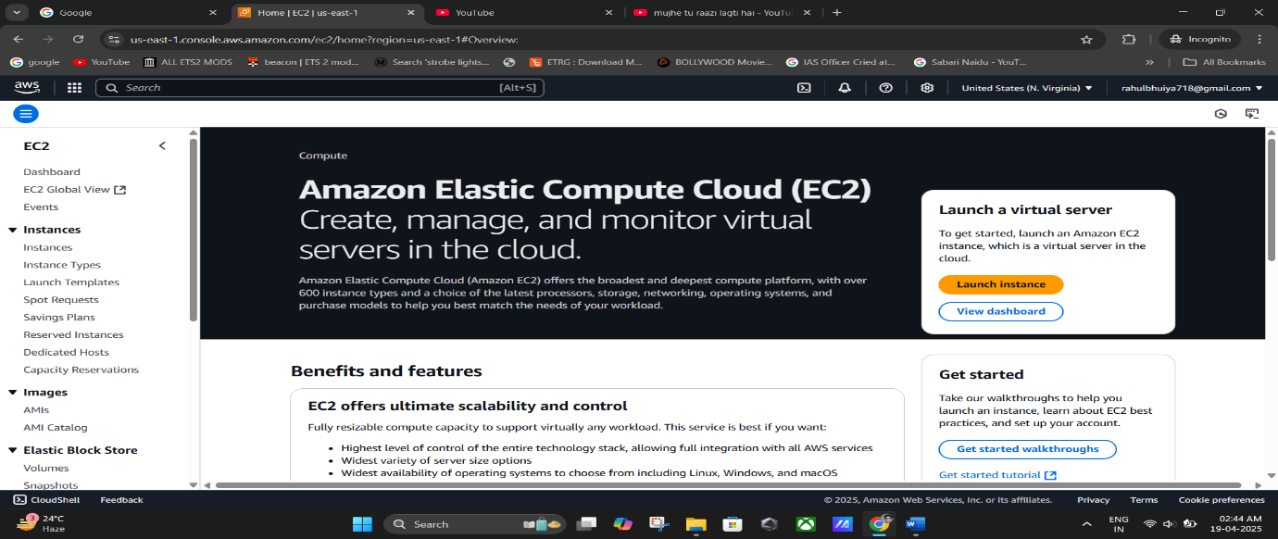➤ RahulWebServer(or any preferred name)

### Choose OS Image (AMI)

➤ Under *Application and OS Images*, select:

### Quick Start

* + - **Ubuntu** (Free Tier Eligible)

### 

### Create or Select a Key Pair

* + - Choose an existing key pair or click **Create new key pair**
    - Give a name like (i.e- Rahul123)
    - Select:
      * **Key pair type**: RSA
      * **File format**: .pem
    - 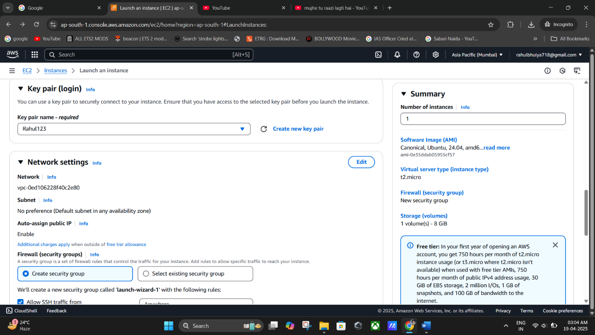Click **Create key pair** and download the .pem file

### Choose Instance Type

➤ Keep default: t2.micro (Free Tier Eligible)

### Configure Security Group (Firewall Rules)

Select *Create security group* and **check all three options**:

* + - ✅ Allow SSH (for connecting to instance)
    - ✅ Allow HTTPS (secure web access)
    - ✅ Allow HTTP (web access)

### 

### Launch Instance

* + - Review summary
    - Click **Launch Instance**
    - On confirmation page, click **“View all instances”**

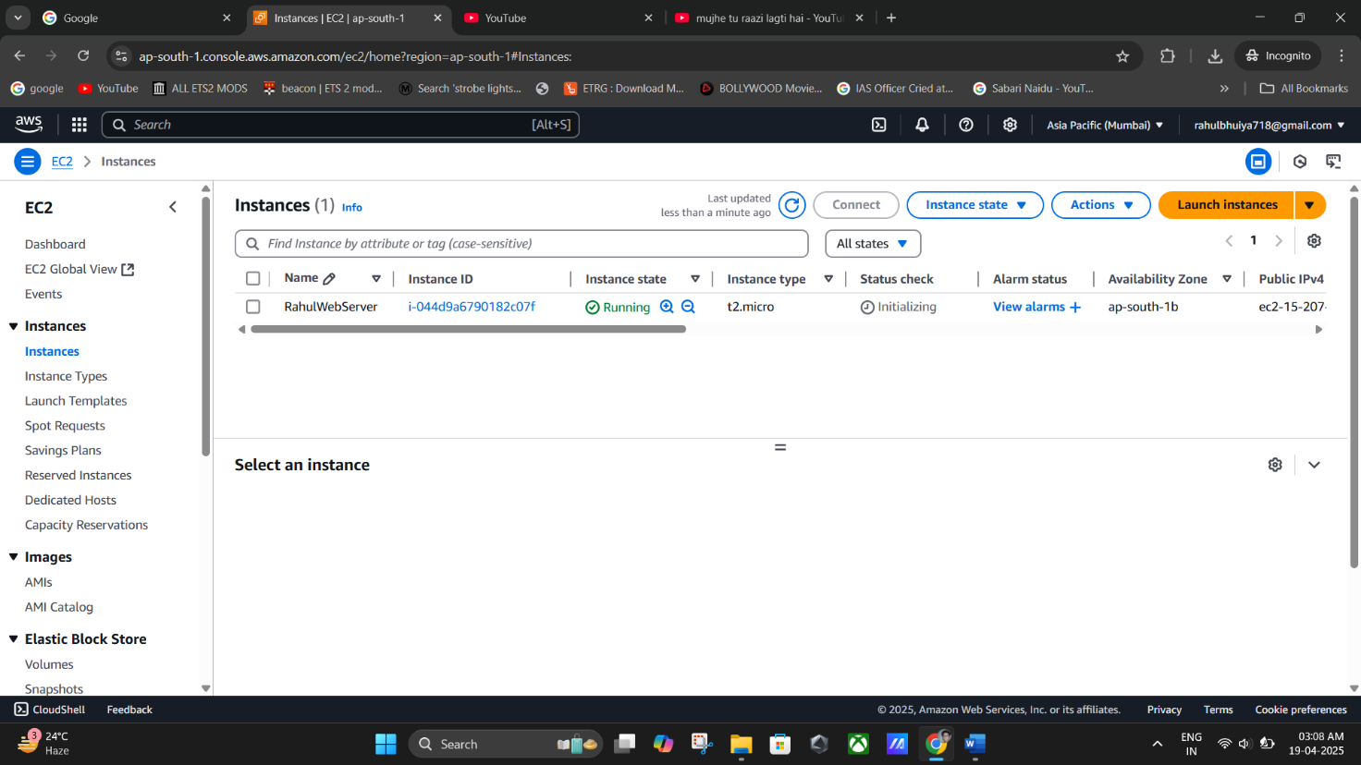

## Observe Public IP Change on Restart

* 1. **Copy current Public IPv4 address** of your instance

➤ Found in instance details pane

### Stop the instance

➤ Actions > Instance state > Stop instance

### Start the instance again

➤ Actions > Instance state > Start instance

### Check the Public IPv4 address again

➤ You'll notice it has **changed**

✅ Confirms why Elastic IP is needed.

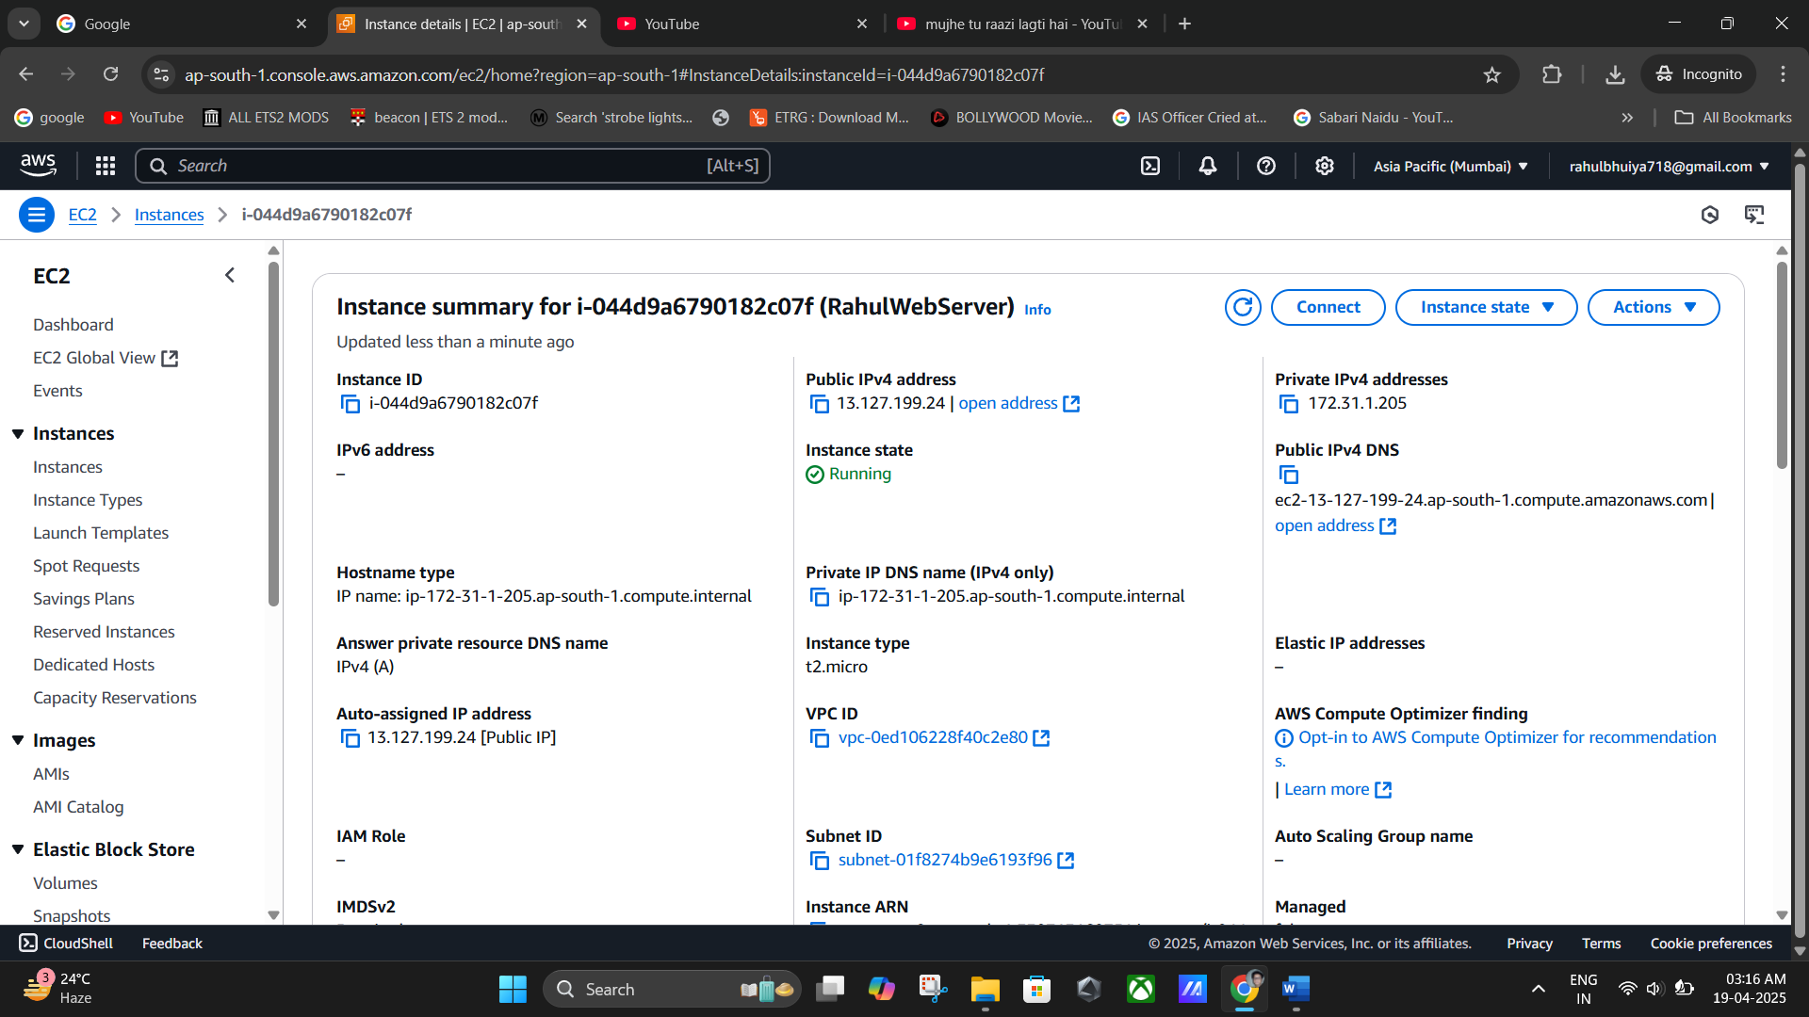

**(Public IPv4 Address Changing again & again while Stopping the instance & stating the instance once gain).**

## Allocate an Elastic IP

* 1. On left menu, go to:

### ➤ Network & Security > Elastic IPs

* 1. Click **Allocate Elastic IP address**
  2. Keep default settings and click **Allocate**

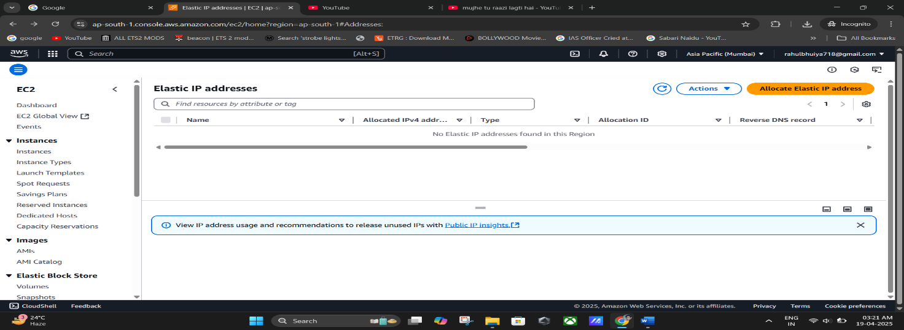

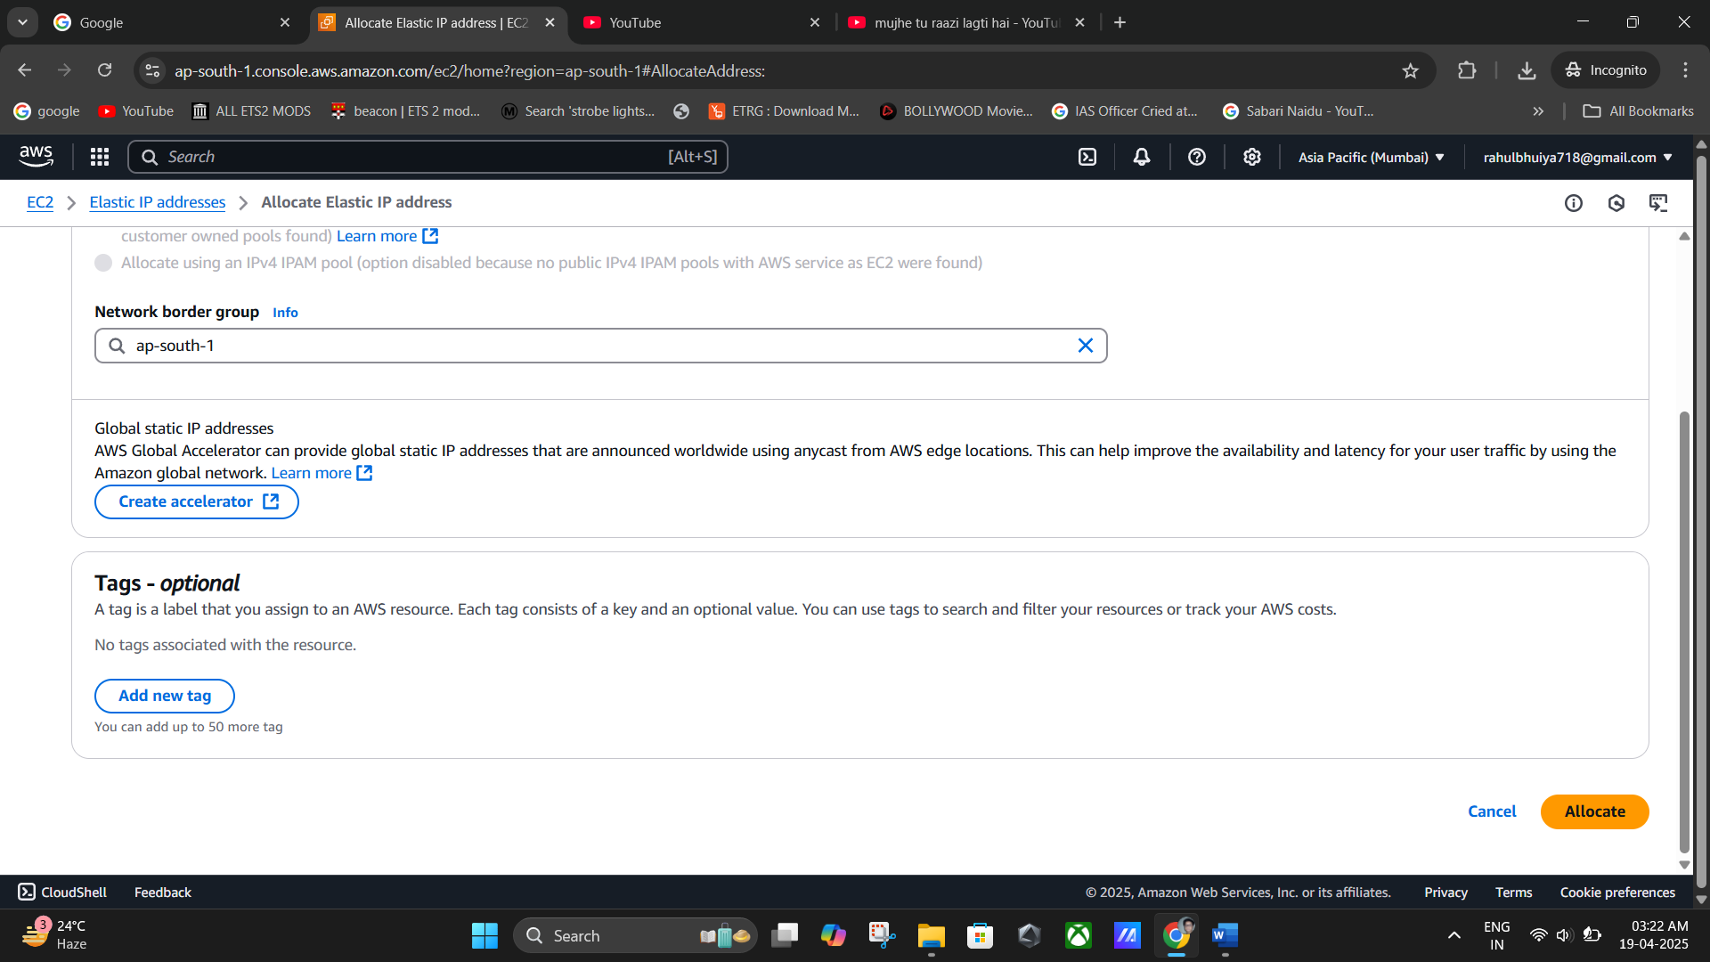

**(Allocate Elastic IP address -> Click “Allocate” Keep Default settings).**

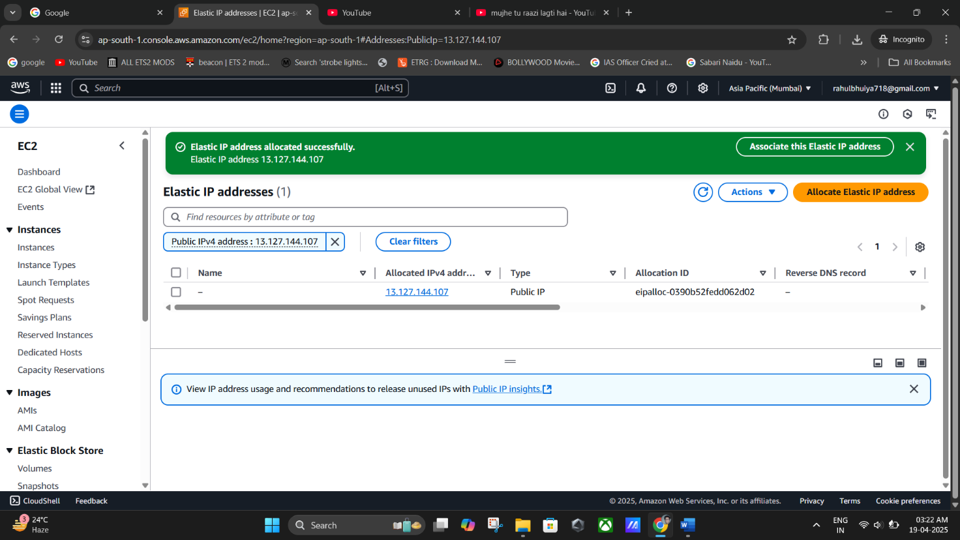

**(Allocation Successfully).**

## Associate Elastic IP with Instance

* 1. Select the newly allocated IP

➤ Click **“Associate Elastic IP address”**

* 1. In the form that opens:
     + **Resource Type**: Select Instance
     + **Instance**: Select your current running EC2 instance
     + **Private IP**: Keep default

### ✅ Check “Allow this Elastic IP address to be reassociated”

* 1. Click **Associate**

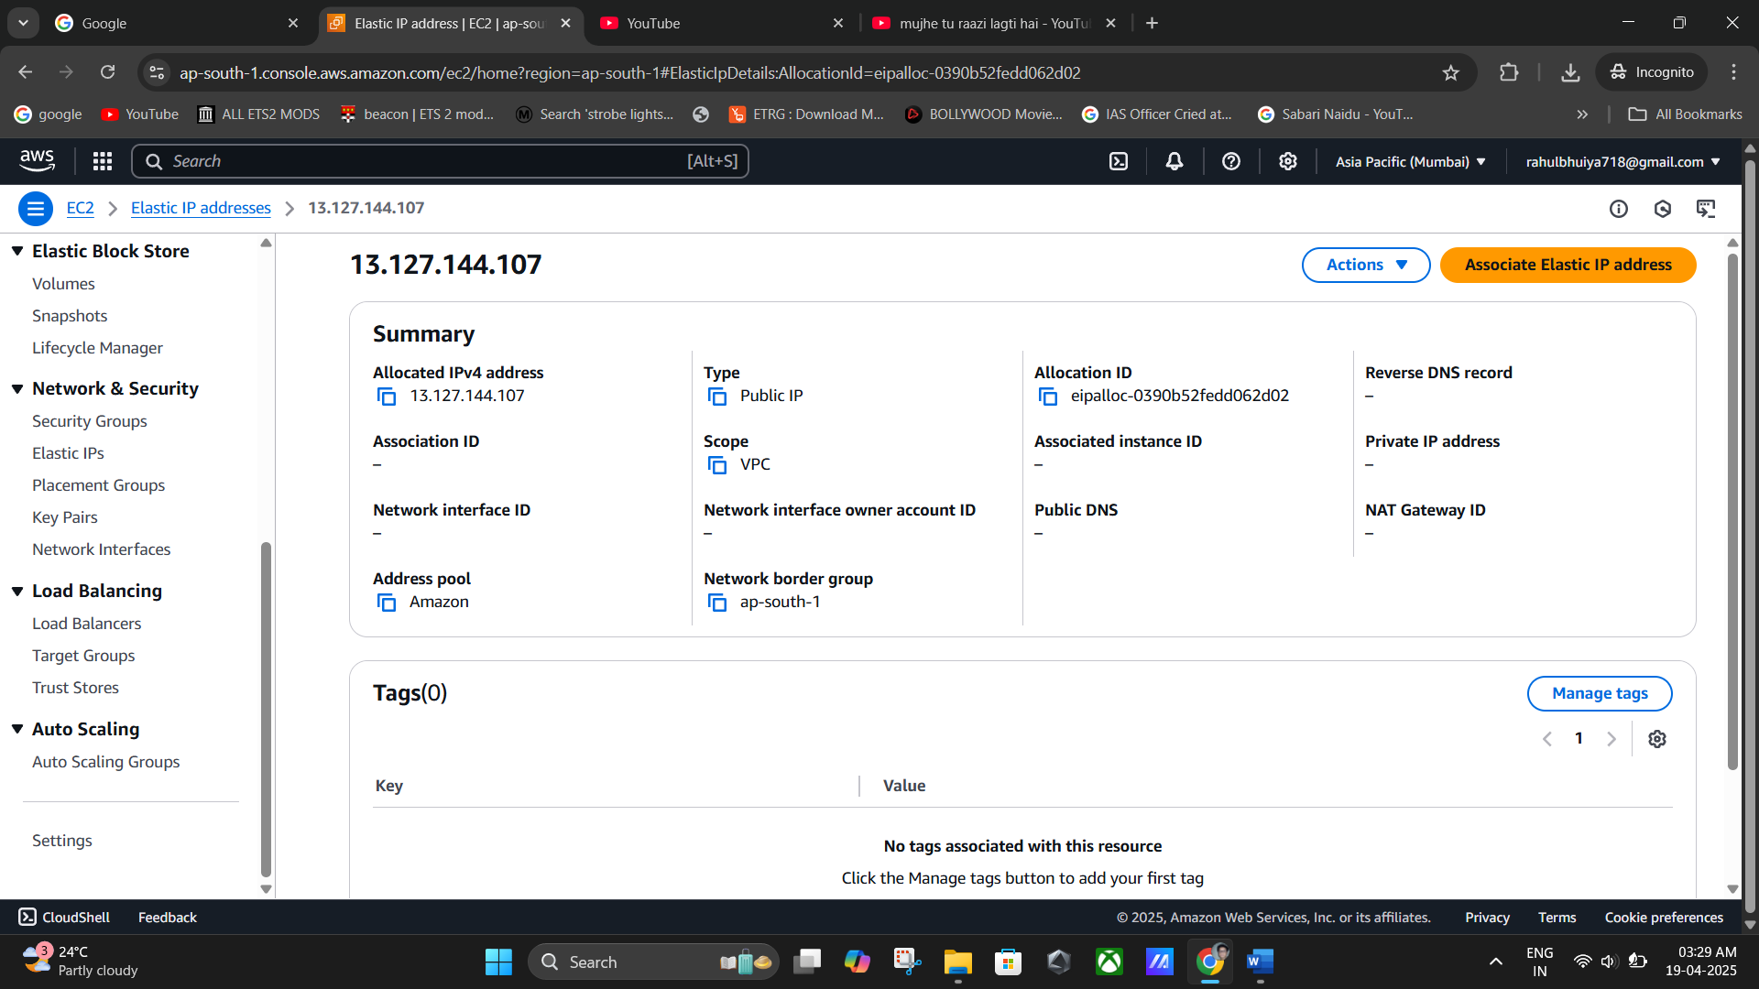

(Click on the newly created **Elastic IP addresses**).

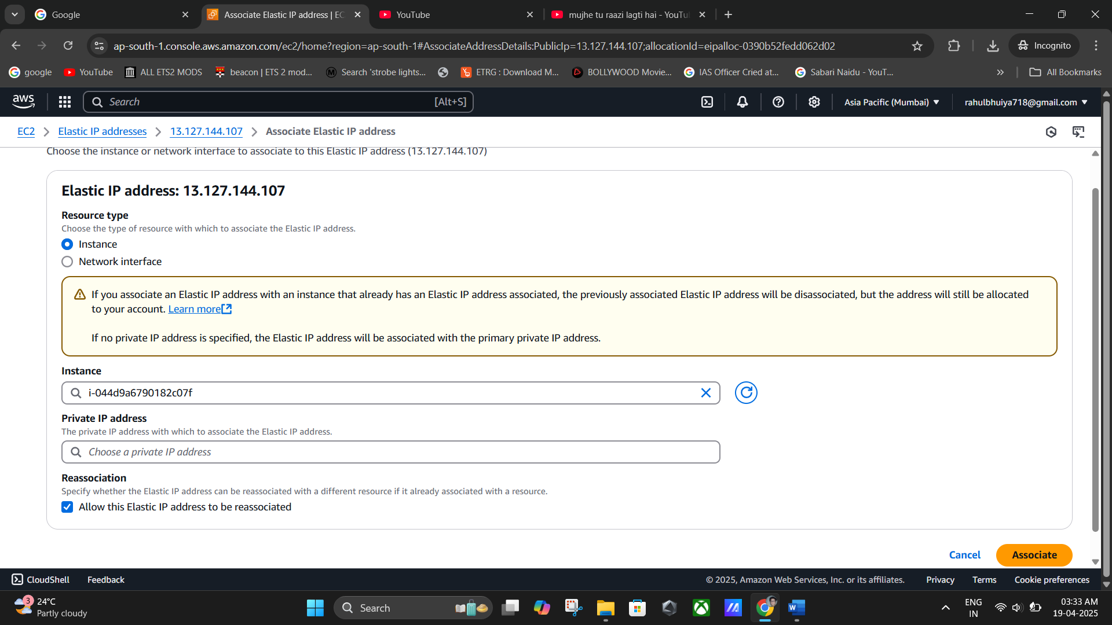

**(Resource Type: Select Instance ->Instance: Select your current running EC2 instance ->Private IP: Keep default).**

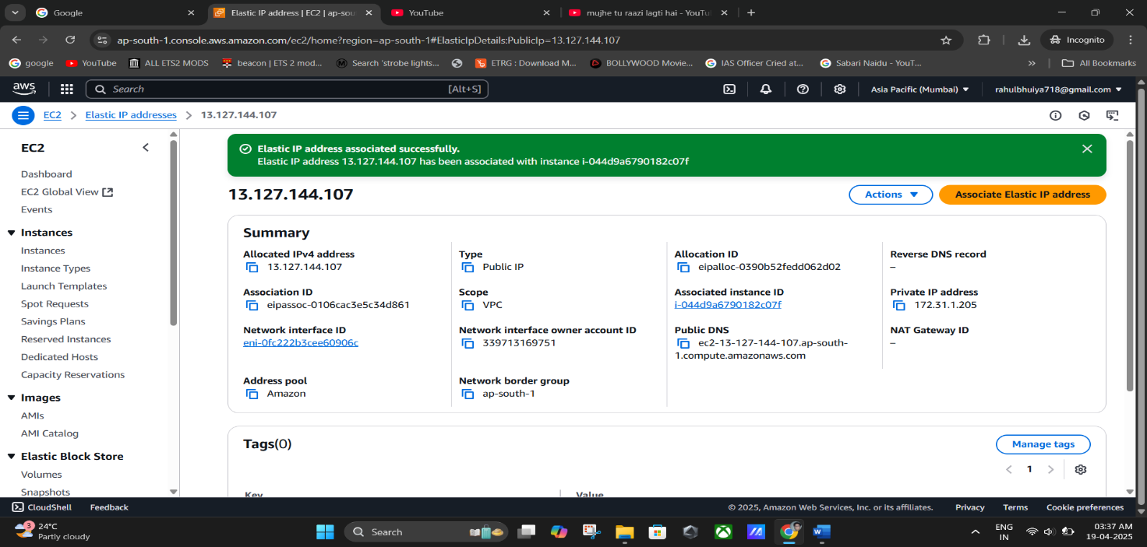

(**Elastic IP address associated successfully**).

## Verify Elastic IP Behaviour

* 1. **Copy current Public IPv4 address** (this is now your **Elastic IP**)
  2. **Stop and start the instance again** as before

### Check the Public IPv4 address again

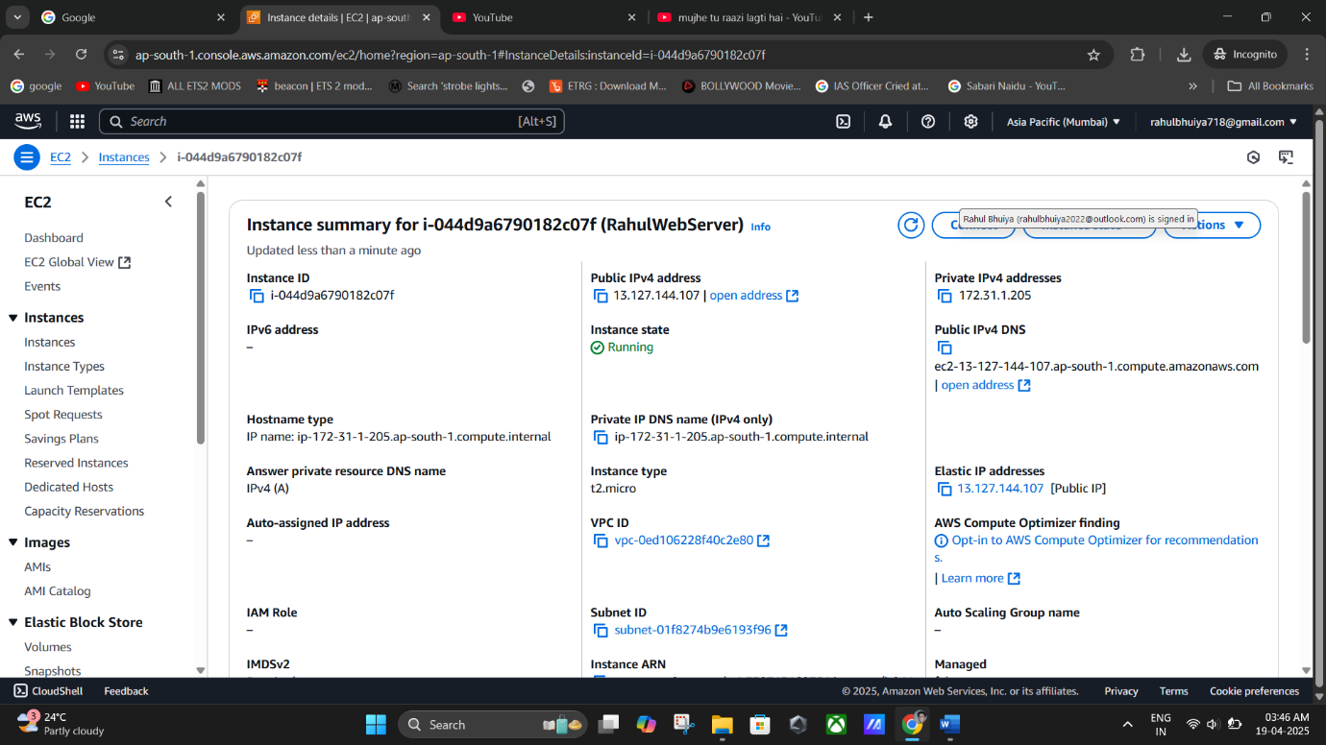➤ You'll see **it hasn’t changed this time** ✅ A Success! Your instance now has a static IP.

**(Public IPv4 Address remains same).**

## Clean Up (Optional)

If you want to remove the Elastic IP:

### Disassociate Elastic IP

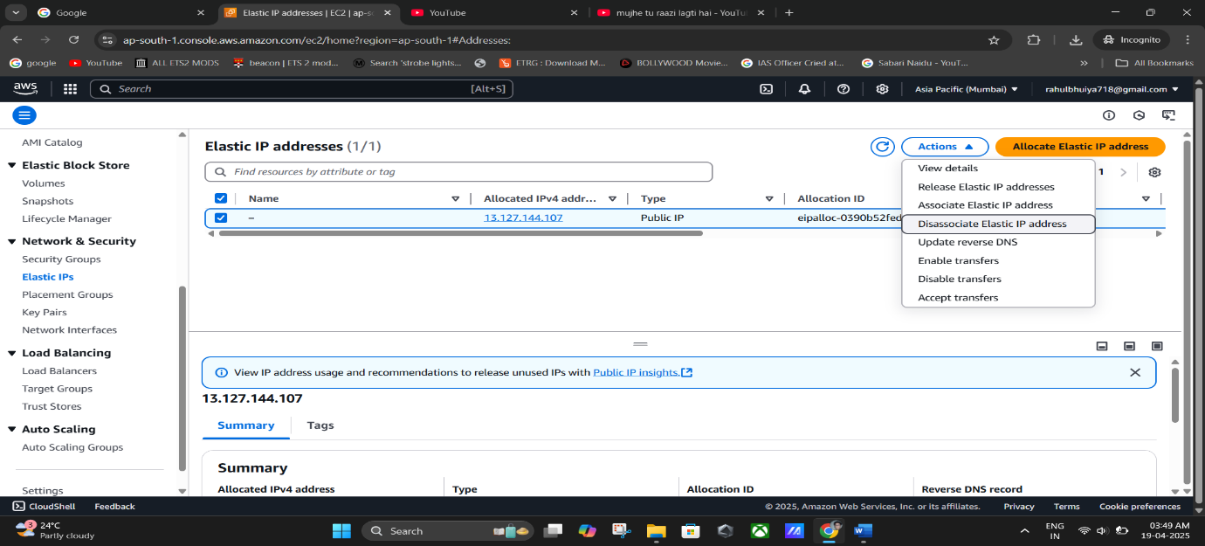➤ Go to **Elastic IPs** > Select IP > Actions > **Disassociate Elastic IP**

### Release Elastic IP

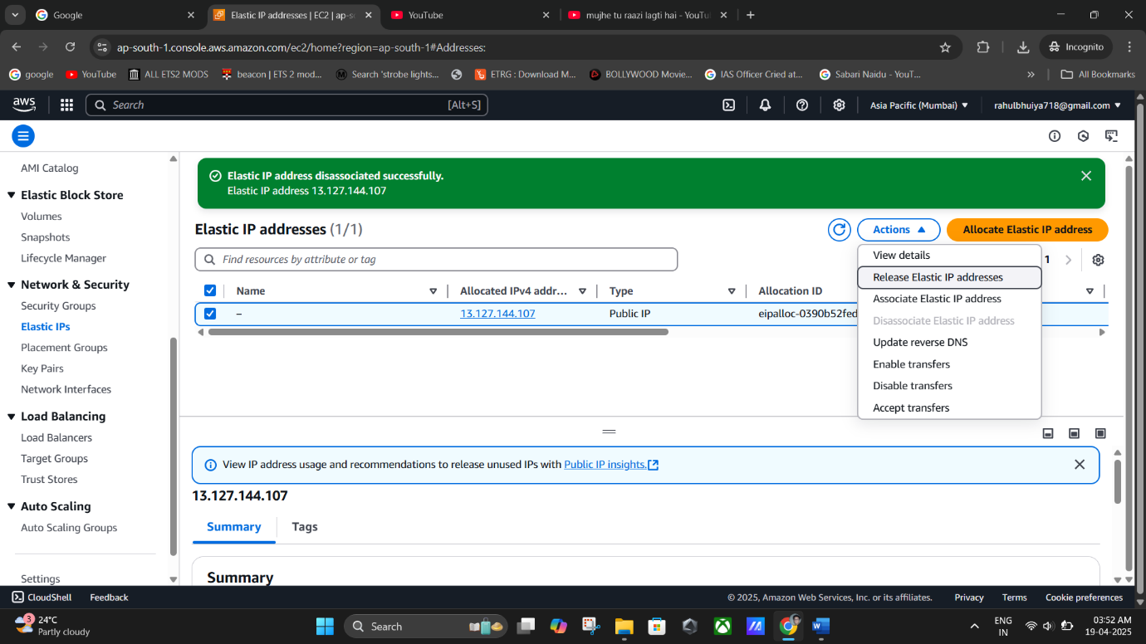➤ After disassociation, select again > Actions > **Release Elastic IP**

(select again > Actions > **Release Elastic IP**).

🎯 **Summary**

|  |  |
| --- | --- |
| **Without Elastic IP** | **With Elastic IP** |
| Public IP changes after restart | Static IP remains the same |
| Manual DNS update needed | No DNS changes required |
| Less reliable for hosted apps | Ideal for hosting apps/websites |